Behavioural Activation (BA) for Young People with Low Mood: Resource Pack

(Age 11+)

Written by:
Dr. Zoe Maiden (Senior Clinical Psychologist) at the N&S CAMHS Trauma, Anxiety and Depression (TAD) Clinic, South London and Maudsley NHS Trust.
With thanks to:
N&S CAMHS TAD team members (past and present) particularly Dr Sarah Miles, Dr Jessica Richardson, Dr Eleanor Leigh and Dr Patrick Smith.
The CYP-IAPT team at Kings College London, particularly Dr Vanessa Buckley.

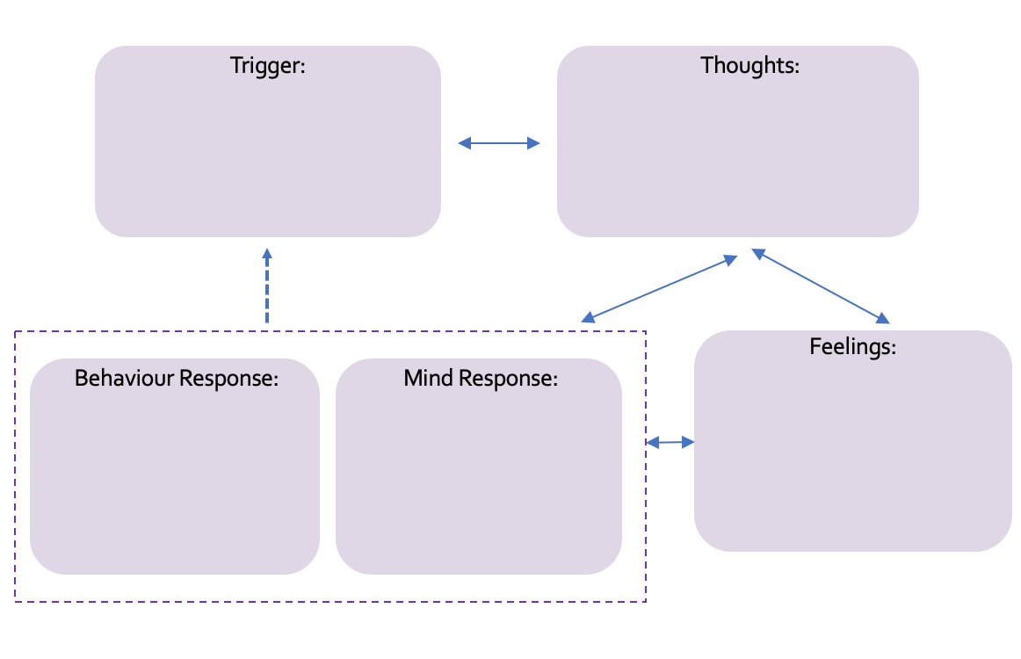

To help us understand what is going on for you at the moment, it can be helpful to think through a recent example of when your problem or difficulty bothered you. With your practitioner, complete the diagram below.

About Low Mood and Depression
What is Low Mood?
We all feel a wide range of different emotions, including happy, sad, angry and scared, at different times. Feeling sad can be a natural and appropriate response to what is happening in our lives. Sadness can also let us know that there is something in our life that we are finding difficult. For example, if a close friend moves away or we don’t do as well in a school exam as we wanted to. Usually, these feelings go away after a few hours, a few days or a few weeks and we get back to being ourselves.

Low mood is different. It means young people feel sad or irritable, for most days of the week, for at least a few weeks (or often longer!). Their low mood also stops them from doing some of the things that they normally enjoy doing. For example, spending time with friends.

Frequently asked questions about low mood
There is no such thing as a stupid question about low mood! Below, we have listed some of the questions that young people have asked us in the past. You and your practitioner can talk through them together and write the answers in the space provided.

What is the difference between low mood and depression?

How common is low mood and depression?

What causes low mood?

Can Social Media cause low mood?

Can negative experiences related to my ethnicity and culture impact my low mood?

Will I always feel like this?

What helps people with low mood?

What does the intervention involve?

What will happen if my mood doesn’t improve?

Are there any other questions you have?

If you would like to find out more about low mood, and other young people’s experiences of low mood, there are some YouTube videos that talk about depression that can be useful to watch:
How do you know if you have depression? (Life Noggin)
The Science of Depression (Life Noggin)
What is Depression? (Therapist Aid)
Low Mood Video for ThinkNinja (Healios Healthcare)
TEDEd: What is depression? (Helen M. Farrell)
TEDTalks: This could be why you’re depressed or anxious (Johann Hari)
TEDxYouth: Conquering depression: how I became my own hero (Hunter Kent)

Understanding more about your own Low Mood
Low mood is different for everyone! Society usually suggests that people with low mood are often crying for most of the day. What we know is that this may be true for some young people with low mood but not all! In fact, most young people will feel irritable (grumpy, snapping at others easily), rather than upset. Low mood can also affect young people in lots of different ways. With your practitioner, think about which of the following apply to you:
Can you tick which ones you think apply to you?
Feeling really sad or miserable a lot of the time

Feeling irritable and/or snapping at people more often

Not wanting to do things that you previously enjoyed

Not wanting to be around people

Sleeping more OR less than usual

Eating more OR less than usual

Having self-critical thoughts

Feeling hopeless about the future

Extreme tiredness and not having any energy

Difficulties concentrating

Crying a lot

Repetitive thoughts of hurting yourself

Thinking about death and dying

Feeling worthless or guilty

Being physically agitated OR unusually slow

Experiencing headaches or tummy aches that are not explained by a physical illness

Think with your practitioner how this applies to you:

In Session BA Worksheet

The activity we are going to complete in today’s session is…

Right now, my mood is: /10
I predict the activity will have the following impact on my:
Sense of ACHIEVMENT: /10
CLOSENESS to others: /10
ENJOYMENT: /10
Now give the activity a go

Sense of ACHIEVMENT: /10
CLOSENESS to others: /10
ENJOYMENT: /10
Right now, my mood is: /10

Activity Diary/Log
A – Achievement (0-10) C = Connection with others (0-10) E= Enjoyment (0-10) V=Valued activity? (Yes or No)
Time/Day
6am – 9am | Mood:  A: C: E: V: | Mood:  A: C: E: V: | Mood:  A: C: E: V: | Mood:  A: C: E: V: | Mood:  A: C: E: V: | Mood:  A: C: E: V: | Mood:  A: C: E: V:
9am – 12pm | Mood:  A: C: E: V: | Mood:  A: C: E: V: | Mood:  A: C: E: V: | Mood:  A: C: E: V: | Mood:  A: C: E: V: | Mood:  A: C: E: V: | Mood:  A: C: E: V:
12pm – 3pm | Mood:  A: C: E: V: | Mood:  A: C: E: V: | Mood:  A: C: E: V: | Mood:  A: C: E: V: | Mood:  A: C: E: V: | Mood:  A: C: E: V: | Mood:  A: C: E: V:
3pm – 6pm | Mood:  A: C: E: V: | Mood:  A: C: E: V: | Mood:  A: C: E: V: | Mood:  A: C: E: V: | Mood:  A: C: E: V: | Mood:  A: C: E: V: | Mood:  A: C: E: V:
6pm – 9pm | Mood:  A: C: E: V: | Mood:  A: C: E: V: | Mood:  A: C: E: V: | Mood:  A: C: E: V: | Mood:  A: C: E: V: | Mood:  A: C: E: V: | Mood:  A: C: E: V:
9pm – 12am | Mood:  A: C: E: V: | Mood:  A: C: E: V: | Mood:  A: C: E: V: | Mood:  A: C: E: V: | Mood:  A: C: E: V: | Mood:  A: C: E: V: | Mood:  A: C: E: V:
Average Mood Rating
(Scale from 0 -10)

Activity Diary/Log
A – Achievement C = Connection with others E= Enjoyment V=Valued activity?
Day/Time | Activity | A  (0-10) | C  (0-10) | E  (0-10) | V?  (Y/N)
Average Mood | Mon | Tues | Wed | Thur | Fri | Sat | Sun

The Importance of Routines
As we found out in Session 1, feeling low can have an impact on our sleep and our appetite; we can sleep more or less than we usually do and we can feel like eating more or less.
Lots of research has shown that the relationship between mood and sleep is bi-directional. This means that whilst feeling low can make sleeping more difficult, sleeping well can also improve our mood. The same has been found with eating; feeling low can negatively affect our appetite, but eating well (regular meals that are nutritionally balanced) can have a positive effect on our mood.
This is why it’s important to try to keep to a routine as much as possible with sleeping and eating. We know this is a lot easier said than done! Have another look at your activity diary with your practitioner, paying attention to your sleeping and eating habits over the last week. What can you notice? Have a think with your practitioner if there are any changes you could try in either of these areas over the next week.
My Sleeping Habits: | Changes I could try:
My Eating Habits: | Changes I could try:


Okay, so values are important, what now?
Step 1: Identifying your values

Cut out these Value Cards and sort them into piles of ‘very important to me’ ‘a little bit important to me’ and ‘not important to me’. Are there any values that you are important to you that are missing? Can you single out your top 3 to 5 values? Once you’ve finished, take a picture with your phone so that you can look back at this when you need to.

Identifying your interests
Often linked to our values, are our interests. Just like you did with values, cut out these interest cards and sort them into piles of most interesting to least interesting. Again, have a think if there are any of your interests that are missing from this list. Can you single out your top 3 to 5 interests? Once you’ve finished take a picture with your phone

Step 2: Exploring your values and interests in more detail:
Now you have identified at least three values and three interests, write them below and expand a bit on why they are important to you. Next, think about how much you’re living in-line with this value at the moment. It may be helpful to have a look at the activity diary you completed this week for homework and look for some examples.

Value/Interest | Why it’s important to me | How much am I living in-line with this value/interest currently? (0 – 10; 0 not at all, 10 all the time) | Examples of activities I did this week in-line with this value
Kamil’s Example:  Sport  Justice/fairness | I like my team mates and it helps keep me healthy  I’ve experienced things that have been unfair in the past | 3  2 | Thought about going to training  Watched a bit of a football game  As fair as I can be to others  Re-posted a Black Lives Matter post

Value/Interest I want to focus on this week:

Activity:

When:

Where:

How:

Help I will need from other people:

Anything that might make it difficult to do the activity?

What can we do to make it easier to complete?

Pros and Cons of Ruminating:
Now that you’re more familiar with ruminating and have started tracking how much you do it, it can be helpful to think about the pros and cons. Fill in the table below with your practitioner.
Pros of Ruminating | Cons of Ruminating

Now think about the following questions together, in relation to something that you often ruminate about (you can choose one of the topics you’ve already identified in our last session or something you’ve been thinking about a lot this week). Add your answers to either the ‘pros’ or ‘cons’ column above:

- What progress has rumination helped me make towards solving a problem?
- What do I now understand about a problem (or my feelings about it) as a result of ruminating that I haven’t understood before?
- How has ruminating about this topic affected my mood? Do I feel more or less self-critical now? Do I feel more or less helpless or hopeless now?

Problem Solving Worksheet
Identify the problem (it’s important to make sure this is just one problem and break it down into smaller steps if needed:

Step 1:

Step 3: Weigh up the pros and cons of each possible solution:

Step 2: Think of all the possible solutions:

Possible Solutions | Pros | Cons
(use another piece of paper if needed)
Choose a solution based on the pros and cons of all available options:

Step 4:

Create a Plan:

When:
Where:
How:
Steps to complete:

Step 5:

Step 6: Execute the plan!
Step 7: Review how the plan went (TBC next week!)
Keeping Things Going
How did the problem develop?
What things led to the problem?
Can you remember when it started? What was happening at that time?
Were there any later experiences that made your problem worse?
What kept the problem going?
What thoughts or beliefs kept it going?
What actions or behaviours kept it going?
What safety behaviours were you using?
What are the most important things you learned in therapy?
How will you continue to build on what you have learned?
What do you need to do to maintain the changes and improvements you have made?
What is there still left to work on?

What might make it difficult for you to keep making progress?
How will you overcome these obstacles?
How would you know if the problems/difficulties were getting worse again?
If you do have a setback, what will you do about it? What would help?
What are your goals for the future?
For the next month:

For the next 6 months:

For the next Year:

What Causes Sleep Problems?
Very rarely does one thing cause sleep difficulties! It is likely a combination of factors that will be different for each and every young person struggling to sleep. Your practitioner will talk you through some of the causes. Make some notes in the boxes below and think about which ones may apply to you.
It’s important to remember, that just like there are lots of things that can contribute to poor sleep, there are lots of things you can do to try and improve it.

Understanding My Sleep Difficulties:
_____________________________________________________________________________________________________________________________________________________________________________________________________________
_____________________________________________________________________________________________________________________________________________________________________________________________________________
_____________________________________________________________________________________________________________________________________________________________________________________________________________
_____________________________________________________________________________________________________________________________________________________________________________________________________________
_____________________________________________________________________________________________________________________________________________________________________________________________________________
You can also have a look at these ‘daily routine top-tips’; think about how they apply to you at the moment and any changes you could make.
Top Tip | Current status | Possible changes I could make
Get daylight exposure (especially in the winter!)
This is linked to ensuring your body clock is working with you, rather than against you.
Be physically active
This doesn’t have to mean running a marathon every day, even a short 10-20 minutes brisk walk has been proven to improve sleep. However, it’s important not to exercise too close to bedtime (within 3 hours before) or it can have the opposite effect!
Reduce your ‘stimulant’ consumption during the day; this includes caffeine, alcohol, nicotine and other substances
Try not to drink caffeine after 3pm; remember there are lots of other caffeine-free alternatives
Don’t eat too late
Being full before bed can wake you up but you also don’t want to go to bed hungry! Limit eating before bed to small snacks. A warm drink can also help.
Restrict in-bed activity
Your brain needs to associate your bed with sleep. Avoid doing anything on your bed, even scrolling through your phone.

Optimising your bedroom
Did you know that your bedroom can affect your quality of sleep? A few tweaks could help!
Top Tip | My Current Bedroom Environment | Changes I Could Make
Cool temperature
Optimum temperature recommended is between 15.6 and 19.4 degrees Celsius

Comfortable bed
Includes your mattress and your pillows!

Block out light
(e.g. black out curtains or sleep mask)
Drown out noise
(e.g. headphones with white noise, ear plugs)
Try calming smells
(e.g. lavender, chamomile)

“I tried an activity and it didn’t help my mood” Worksheet
- Was it in line with your values?

- The importance of context and consequences
What is going on around the activity and what the consequences are of the activity are sometimes more important than the activity itself! Let’s break down what happened to think about this:
What was going on before the activity? | Details of the activity  (Who, where, when, what) | Consequences: What happened after the activity (short-term and long-term)
Came home from school | Went to my room, sent a message to Nathan to try to arrange to meet up tomorrow. Scrolled on social media in between. | Mum shouted at me for being on my phone instead of doing my homework; I felt guilty for not doing my homework. I stopped messaging Nathan
Anything in the context or consequences that could explain why the activity did not have a positive impact on your mood?
- Where was your attention during the task? Were you fully engaged in the activity or were you ‘stuck in your head?’ Were you ruminating?
If you’ve worked through 1-3 and there does not seem to be an explanation. Sometimes, annoyingly, it can take our mood some time to catch up with our change in activities. Was this the first time you have tried this activity?

